**OSAMA SAGHEER  
BCS211074**

**SECTION 1**

**PRACTICE TASK LAB 5**

**TASK 1:**

Write an assembly language program that allow user to input one-digit number and determine if it is even or odd.

**CODE:**

.model small

.stack 100h

.data

num db ?

msg db 0ah, 0dh, "Enter a one-digit number: $"

msg_even db 0ah, 0dh, "The number is even. $"

msg_odd db 0ah, 0dh, "The number is odd. $"

.code

mov ax, @data

mov ds, ax

lea dx, msg

mov ah, 9

int 21h ; display message to enter a one-digit number

mov ah, 1 ; read one-digit number from user

int 21h

sub al, 30h ; convert from ASCII to decimal

mov ah, 0 ; check if number is even or odd

mov bl, al

and bl, 1 ; check the least significant bit

jz even

jmp odd

even:

lea dx, msg_even

jmp display

odd:

lea dx, msg_odd

display:

mov ah, 9

int 21h ; display message if number is even or odd

mov ah, 4ch ; return control to operating system

int 21h

end

**OUTPUT:**

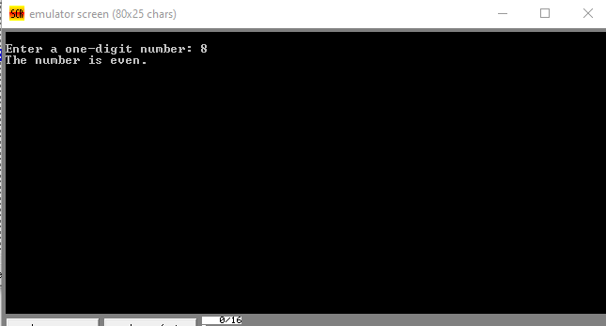

**TASK 2:**

**CODE:**

.model small

.data

msg1 db 'Enter the grade (1-10): $'

msg2 db 0ah,0ah,'Your grade is: $'

A db 'A$'

B db 'B$'

C db 'C$'

F db 'F$'

.code

mov ax, @data

mov ds, ax

mov ah, 09h ; print message to enter grade

lea dx, msg1

int 21h

mov ah, 01h ; read a single character from keyboard

int 21h

sub al, 30h ; convert ASCII value to decimal

cmp al, 8

jge grade_A ; A grade if value is 8,9

cmp al, 5

jl grade_F ; F grade if value is less than or equal to 2

cmp al, 7

jle grade_B ; B grade if value is 5,6,7

cmp al, 4

jle grade_C ; C grade if value is 3,4

grade_A:

mov ah, 09h ; print A grade

lea dx, A

int 21h

jmp end_prog

grade_B:

mov ah, 09h ; print B grade

lea dx, B

int 21h

jmp end_prog

grade_C:

mov ah, 09h ; print C grade

lea dx, C

int 21h

jmp end_prog

grade_F:

mov ah, 09h ; print F grade

lea dx, F

int 21h

jmp end_prog

end_prog:

mov ah, 09h ; print new line character

lea dx, msg2

int 21h

mov ah, 4ch ; return control to DOS

int 21h

end

**OUTPUT:**

